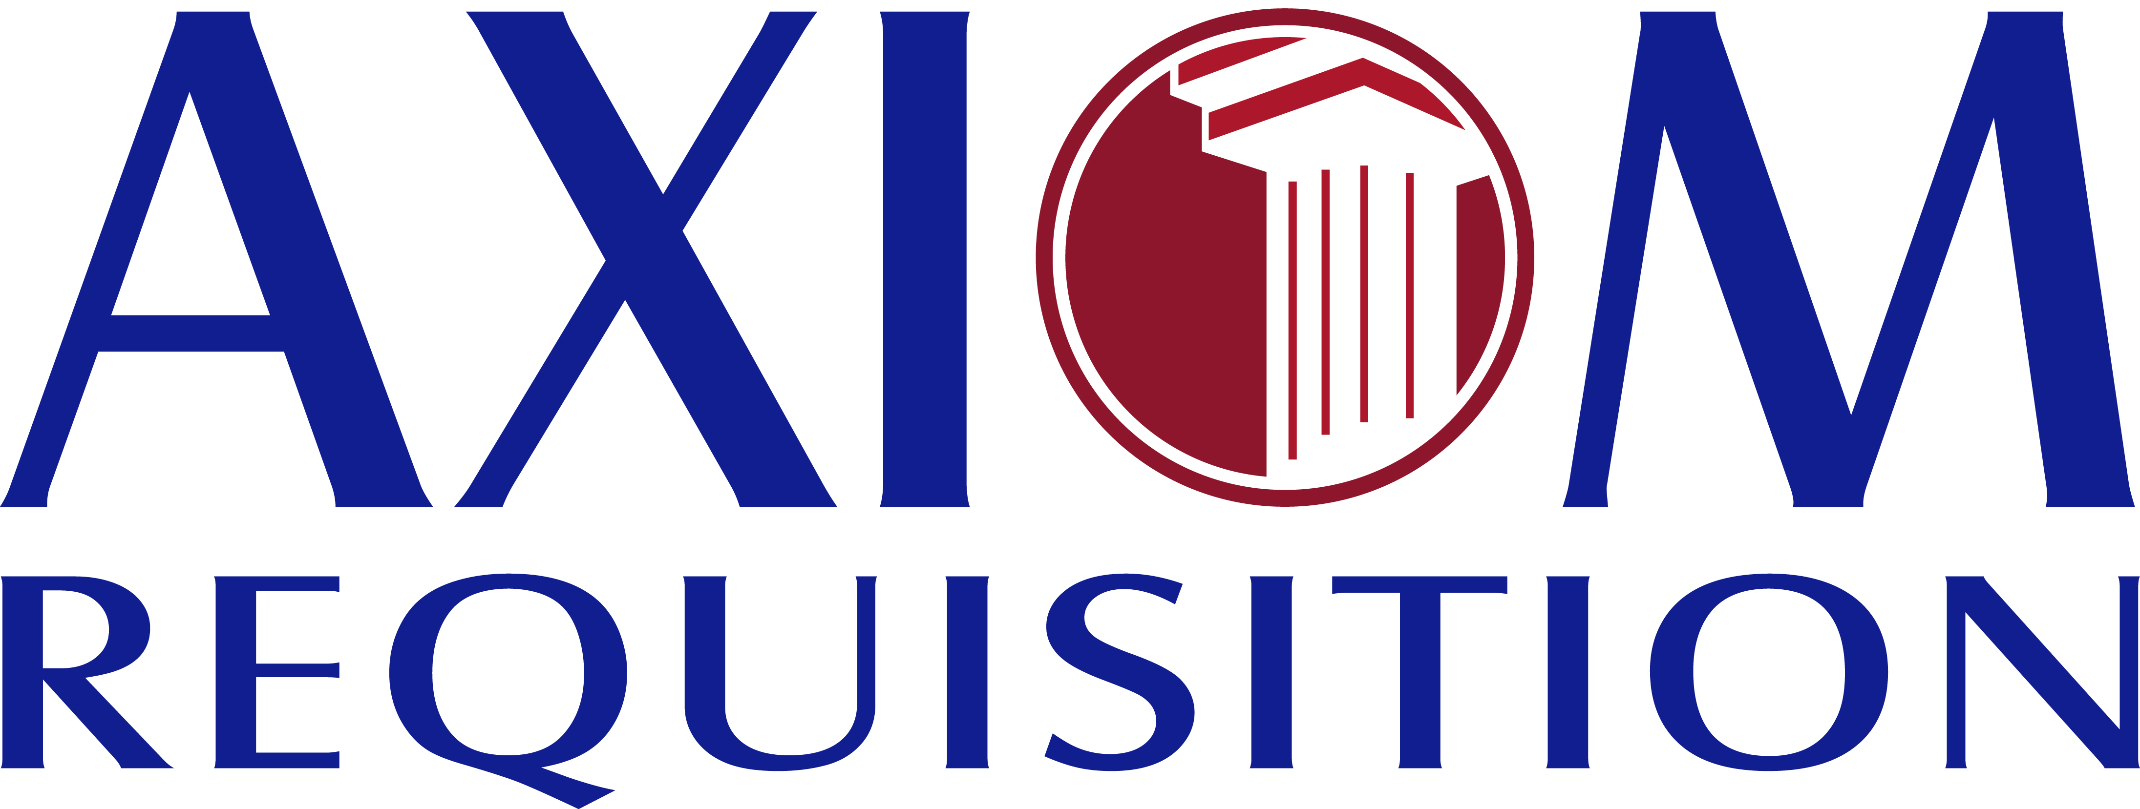

TO THE CUSTODIAN OF RECORDS
University of Michigan Hospital and Health Center Release of Information Unit
Dept. Release of Information Unit - NCAC
2901 Hubbard Street Room 2722
Ann Arbor, MI 48109-0000

RE: Batman
DOB 01/01/1979 SSN xxx-xx-5555

Dear Krystle,

We are in receipt of the records for the above-mentioned individual.
THIS IS NOT ANOTHER REQUEST FOR RECORDS. However, the Certification was not signed and this is required by our client. Please sign and return this form at your earliest convenience.
If you should have any questions regarding this matter, please do not hesitate to contact me.
Thank you for your assistance in this matter.

Account Executive

Order No. 01-29018-002

CERTIFICATE CONCERNING MEDICAL REPORTS

I, ___________________________, hereby certify, in accordance with M.G.L. Chapter 233, §79G, that the attached medical records as requested below are true and genuine copies of the original records concerning Batman and said records accurately reflect the diagnosis, prognosis and opinion concerning said patient.

Signed under the pains and penalties of perjury this _______ day of __________, 2009.

_______________________________________________
Signature

Order No.: 01-29018-002

